DELHI PUBLIC SCHOOL MAKRONIA
Summer Holiday Homework 2026-2027
Class - 3rd A and B
S. No. | Subjects | Assignment | Instructions of doing assignment
1 | English | 1.Creative writing  - Finish the story.  - Underline Noun.  - Underline Pronouns.  2. Cursive Handwriting ( Book )  Page number 05 to 20 .  3. English Communicate with Cambridge.  Poem – 1 The Tree Hippopotamus.  Lesson – 3 How the Sun was Rescued.  Write the synonyms of the difficult words. You may choose any 15 to 20 difficult words from the lesson 3 and the poem 1.  4. Writing work.  Write one paragraph about your summer vacation. Describe what you did during your summer vacation and the places you visited. | - Do all the work on A4 size paper.  - Staple (pinch) all the pages together  - properly.
2 | Hindi | Q1- बारह खड़ी पढ़े और लिखें|  Q2-मात्रा की परिभाषा लिखें|  Q3- पाँच फलों का चित्र बनाये तथाउनके नाम लिखें|  Q4- महात्मा गाँधी का चित्र चिपकायेतथा उन पर पाँच पंक्तियाँ लिखें|  Q5- प्रकृति से सम्बंधित चित्र बनायेतथा अपने शब्दों मे कोई एक कवितालिखें| | दिया हुआ कार्य A 4 फाईल पेज मे सुंदरलिखावट मे पूर्ण करें
3 | Maths | Writing work  1.Write and Learn the table  2 to 15  2. Solve the mathematical problems given in the work sheet  3.Solve the reasoning worksheet (Take out prinout) | Solve the worksheet in A4size Ruled paper and club all  the papers in a file
4 | Evs | Class 3  1. Make a colourful scrapbook of different communities and food.  2. Food Plate Craft: Use a paper plate to show healthy food.  3. Write about 5 sense organs with pictures  4.Do picture study of chapter 1& chapter 2  5.Learn chapter 1& chapter 2 | 1. Do all the work on A4 size paper. & Staple (pinch) all the pages together properly.
5 | Computer | Q.1.Type your Name, Father’s name, Mother’s name, Class name and School name using Computer.  Q.2.Write (4-5) lines on Input and Output Devices?  Q.3.Fill in the crossword: | - Do all the work on A4 size paper and keep it in a separate file.  Follow the instruction properly.  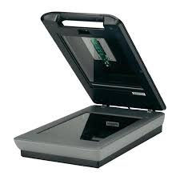
  Down ()  1. Used for drawing.  3. Used to copy images.  Across ( )  2. Used for typing.  4.Used to listen to music. | 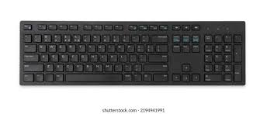
  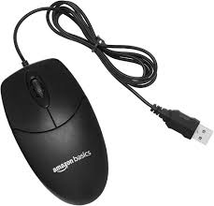 | 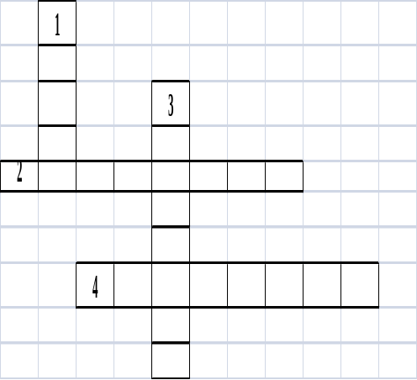 | 